Diploma Program Details

Animation & Game Design (Basic)

Overview
A 6-month certified course designed to introduce students to the fundamentals of Animation and Game Design, with a focus on developing creative, technical, and storytelling skills.

Learning Outcomes
- Understand the basics of 2D animation.
- Develop character design skills.
- Learn fundamentals of game design.
- Develop storyboarding and visual storytelling skills.
- Create basic games and animations.
- Build creative skills for future career opportunities.

Topics Covered
- Fundamentals of 2D Animation
- Character Design
- Game Design
- Storyboarding
- Animation Concepts
- Basic Game Development
- Creative & Visual Storytelling

Eligibility
Matriculation or Equivalent with Basic Computer Knowledge

Registration Fee
PKR 8,000

Per Month Fee
PKR 10,000 per month

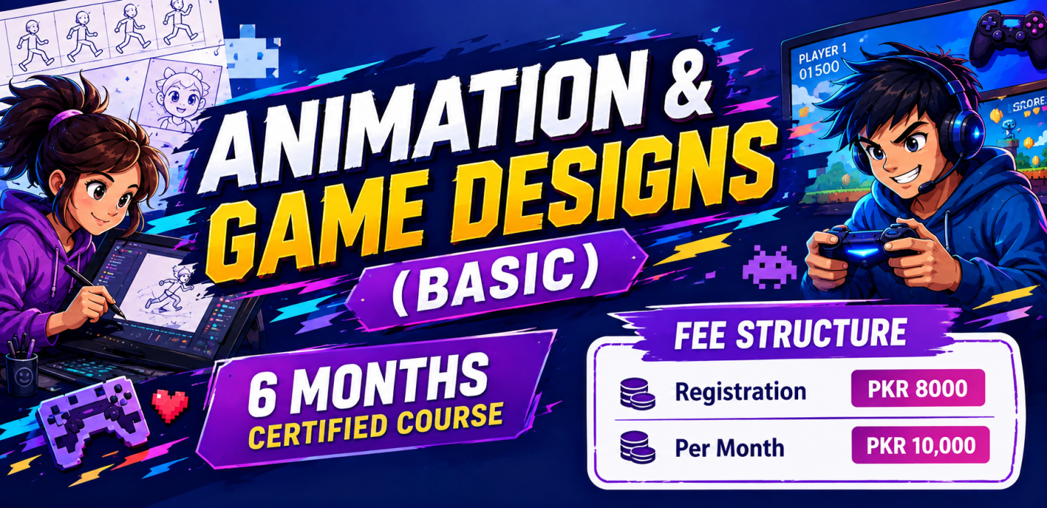

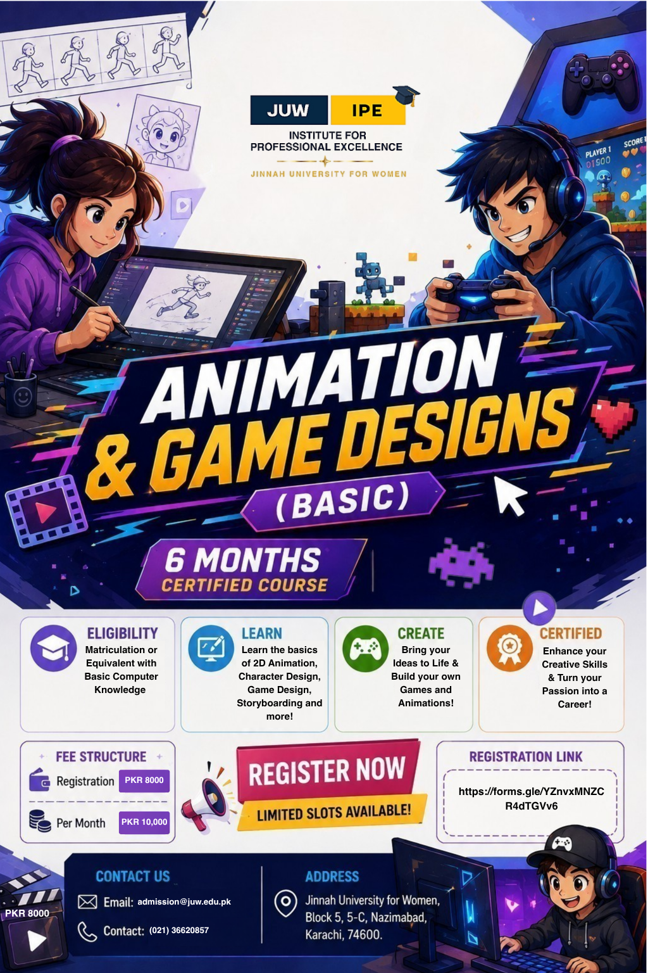

Animation & Game Design (Advance)

Overview
A 1-year diploma program designed to provide comprehensive training in Animation and Game Design, progressing from basic concepts to advanced techniques and industry-oriented projects.

Learning Outcomes
- Develop skills in 2D and 3D animation.
- Create and design characters and game environments.
- Learn professional game design techniques.
- Develop storyboarding and visual storytelling skills.
- Use industry-standard tools and techniques.
- Work on real-life projects and develop a professional portfolio.
- Build skills for career opportunities in the animation and gaming industry.

Topics Covered
- 2D Animation
- 3D Animation
- Character Design
- Game Design
- Storyboarding
- Animation & Game Development
- Industry-Standard Tools & Techniques
- Advanced Animation & Game Design
- Real-Life Projects

Eligibility
Matriculation & Equivalent with Basic Computer Knowledge

Registration Fee
PKR 8,000

Per Month Fee
PKR 10,000 per month
